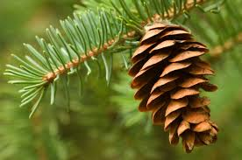
Pine Cone Reading Goal Slips
Please turn in each slip as your child meets each goal.

My child ________________ read ____ books. Please return this slip to the iCenter staff at school to get a prize.
Parent Signature:

My child ________________ read ____ books. Please return this slip to the classroom teacher at school to get a prize.
Parent Signature:

My child ________________ read ____ books. Please return this slip to the classroom teacher at school to get a prize.
Parent Signature:

