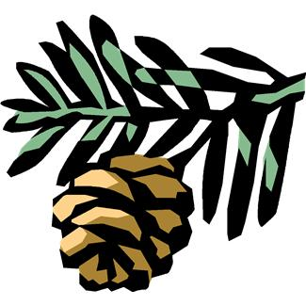
Pine Cone Response Form

Student Name:______________________________________________

Title:_____________________________________________________

Author:___________________________________________________

This book was read: ____to me ____ with me ____by me

Write about your favorite part of the book:

_____________________________________________________________________

_____________________________________________________________________

_____________________________________________________________________

Draw a picture about your favorite part of the book:

Parent Signature_____________________________________________

